.  HEALTHY GENERATION PROJECT  2017-1-SK01-KA219-035296_1  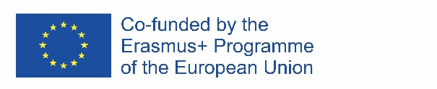  GR: 2nd school of Mikra, Trilofos  RO: Scoala Gimnaziala "Grigore Moisil", Ploiesti  SK: ZŠ sv. Andreja Svorada a Benedikta Skalité | 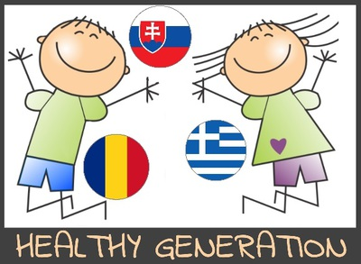

Questionnaire 2 Results / March 2019 /
Greece | Romania | Slovakia

